**Fris Control**



**Intense 1v1 frisbee stand off**

Contents

**a. Thow a frisbee to score points and win 3**

**b. Story and Themes 3**

**c. Genre 3**

**d. Target Audience 3**

**e. Platform and Tolls 3**

**I. Playability and Mechanics 3**

**a. Main Game View 3**

**b. UI 4**

**c. Power Throw 4**

**d. Tricky Throw 4**

**e. Fast hands 4**

f. Falling meanace 4

**g. Game Controls 5**

**II. Core Gameplay Loop 5**

**III. Game Elements 5**

**a. Main Characters 5**

**b. Intro Sequence 5**

**c. End Condition 6**

**IV. Sound 6**

**a. Music 6**

**b. Sound Effects 6**

**VI. Mini Art Bible 6**

a. Art Style 6

b. Characters 6

c. Backgrounds/Levels 7

**Game Overview**

## **Thow a frisbee to score points and win**

Chose a power and enter a 1V1 match against someone either online or lan. Throw a frisbee towards your opponent goal, if they don’t catch the frisbee you score a point if they do, they get the option to throw the frisbee back to you. The game is inspired in “windjammers” and it is basically a VR reimagination of it.

## **Story and Themes**

There would be a story mode where the player goes to the beach, asks to play a bit and without realising join a tournament. But there would not be a “proper” story for the game.

## **Genre**

Sports, Action, VR.

## **Target Audience**

E, for everyone (but over the age of 6 or 8 probably).

## **Platform and Tolls**

Platform: VR;

Coding: Unreal Engine/C++ (better graphics control);

3D modeling: Blender;

music: TBD.

# **Playability and Mechanics**

## **Main Game View**

First person view.



## **UI**

TBD

## **Power Throw**

By pressing a key when the player has their meter full, the disc will glow and when throwing it will create a specific throw pattern (based on power chosen).

This meter will slowly charge over time, to speed the proces of charging the player will need to catch the disc with a certain timing and release it quickly, and/or suffering goals.

## **Tricky Throw**

The discs will always be thrown at a minimum height to be able to pass throw the net or from a low point to a high one, but the player will have the option to try to throw it, by pressing a button, in a way that it will not go towards the goal but so it stops mid air and falls to the ground.

## **Fast hands**

The faster you catch and throw the disc, the faster it will accelerate, giving a boost to players that are able to perfectly time their catches and throws.

## **Falling meanace**

For the disc to fall it will need to stay afloat for some time, throwing it against the wall will almost always give it a speed boost to make it less common for the disc to fall.

## **Game Controls**

a

| Key binds | Function |
| --- | --- |
| Grab | Grab the disc |
| Pinch | Tricky throw |
| A | Power throw |
| B | TBD |
| X | TBD |
| Y | TBD |
| Left menu | Menu |

# **Core Gameplay Loop**

Throw the disc and don’t let it fall or reach your goal, that’s literally it.

# **Game Elements**

## **Main Characters**

* **“Insert Player Name”:**

Characters are blank avatars.  
 **Main Menu**

a

[How are you planning to structure the main menu? Does it have a background? Does it show the game while using it? what’s going to be the purpose of your main menu?]

## **Intro Sequence**

If the player choses the story option (PvE), it will start with the player watching their chosen avatar walking towards a beach and asking to play, they are then written on a board and start playing.

## **End Condition**

If the player choses the story option (PvE), it will end when the player defeats the last opponent in the tournament. They will go up to a podium, receive cheers and the game fades back to the main menu.

# **Sound**

## **Music**

TBD

## **Sound Effects**

TBD

# **Mini Art Bible**

## **Art Style**

TBD, but something more realistic for the environment and objects

## **Characters**

All images are from the game “Echo VR”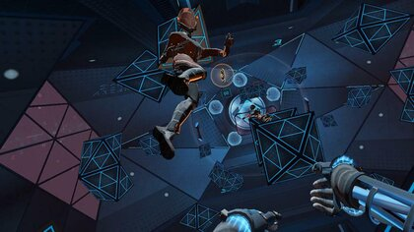

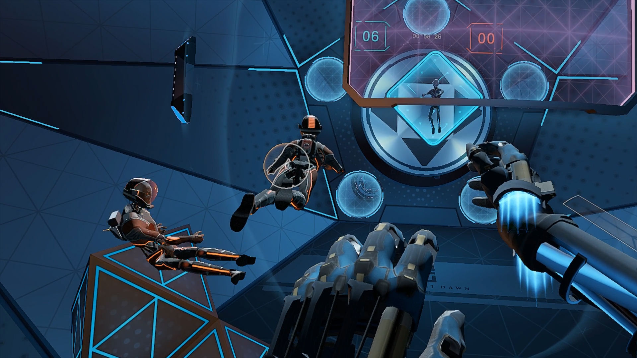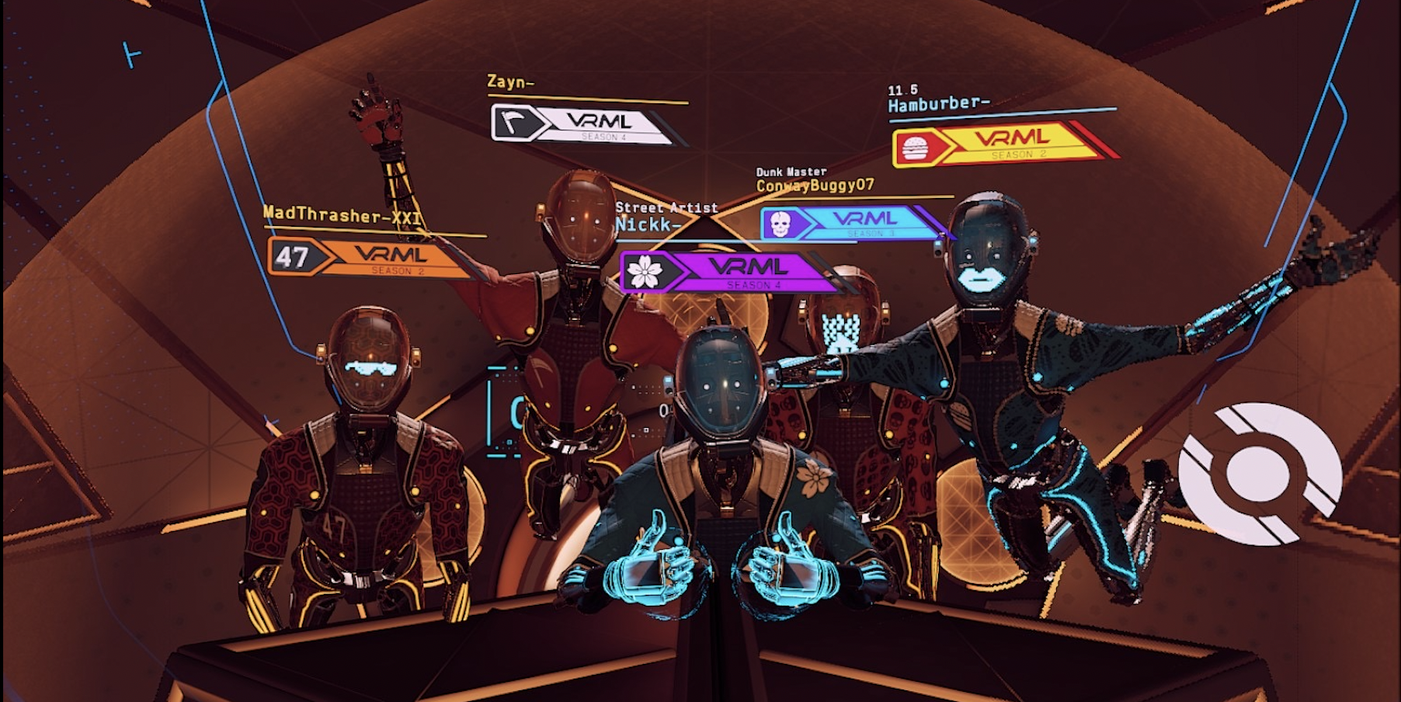

## **Backgrounds/Levels**

TBD, but something more realistic for the environment and objects

**The team:**

**[put your name and contact here alongside your position if interested.]**